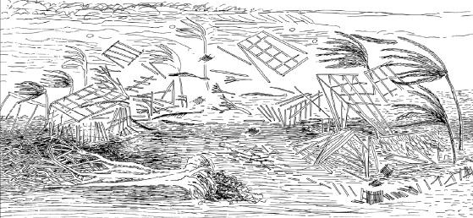

## Crime Rates In Relation To Natural Disasters

Data Analysis

Oleg Mironov | Amy Reynolds | Mariam Hassan | Kundyz Smith

# Do Natural Disasters Induce More Crime?

***Scope***

Natural disasters impose great loses economically, and socially. The objective of this research and analysis is to answer three questions. 1. Whether natural disasters have a direct correlation between crime rates. Furthermore, we were interested in discovering if the correlation shows an increase, a decrease or relative stability in terms of crime. 2. If data is even abundant and detailed following the disaster(s). 3. What factors affected crime following the natural disaster.

To present our case, we evaluated crime report data from Hurricane Ike, a hurricane affecting Galveston and surrounding areas in September 2008, and data from a major earthquake in Virginia in August 2011. These two locations are good exploratory ground for data analysis because of the difference in economies between two states, population, city density, and many other factors. This would give us a diverse representation of crime. To carefully analyze a trend, we looked at the year before and after in each instance. Crime in our analysis consisted of felonies and misdemeanors, with an emphasis on robberies. We predicted robberies would have the highest influx post-disaster.

Surprisingly so, information for the social/crime impact was limited. For the years needed, we looked into national police agencies that reported crime trends and out of ___ , only 64 agencies reported. Initially, we were looking to get data on Hurricane Katrina as a comparison choice, but that proved unlikely as there was not sufficient, pertinent data out there.

***Data Exploration***

The data exploration process comprised of the following steps, separately for each state.

1. First, we pulled data from police stations, nation-wide.

2. We explored data by selecting the police station with data in the affected natural disaster zone.

3. Then, we plotted the police station information in heat maps.

4. We then analyzed and cleaned the data into a useable format.

5. We repeated the steps for the other natural disaster